**UNIT-5: SPACE APPLICATIONS**

**Types of Orbits**

Circular Orbits (e = 0)

Circular orbits are the simplest type of orbit. In a circular orbit, the orbiting body maintains a constant distance from the central body. This means the **speed** of the orbiting body is also **constant**.

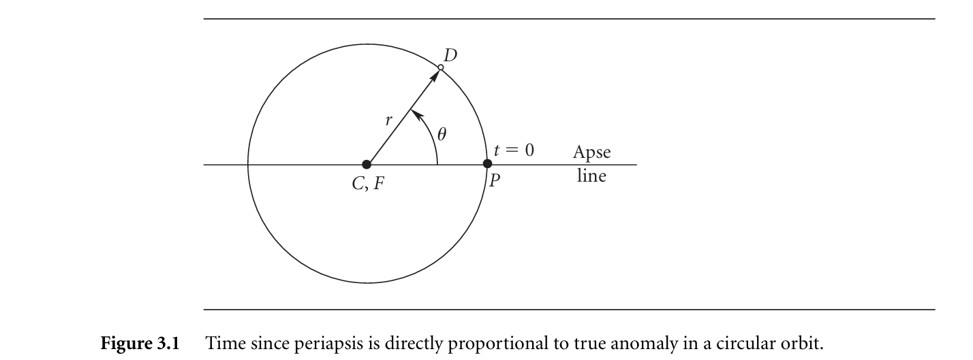

Elliptical Orbits (0 < e < 1)

In an elliptical orbit, the distance between the orbiting body and the central body changes throughout the orbit. The point of closest approach is called **periapsis** and the point of farthest distance is called **apoapsis**.

Elliptical orbits are characterised by their **eccentricity (e)**, a value between 0 and 1. An eccentricity of 0 is a circular orbit. As eccentricity increases towards 1, the ellipse becomes more elongated.

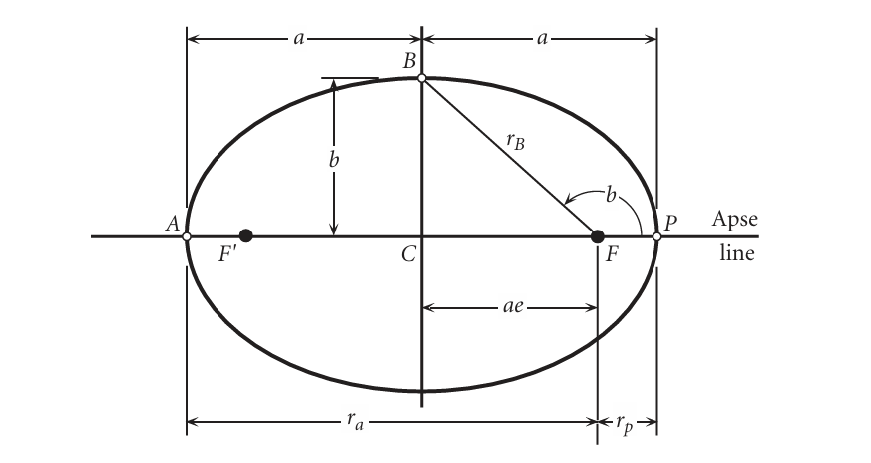

Parabolic Trajectories (e = 1)

Parabolic trajectories are the boundary between elliptical orbits and hyperbolic trajectories. A body on a parabolic trajectory has just enough energy to escape the gravitational pull of the central body.

The velocity of a body on a parabolic trajectory **decreases** as it moves **away** from the central body, approaching zero at an **infinite** distance.

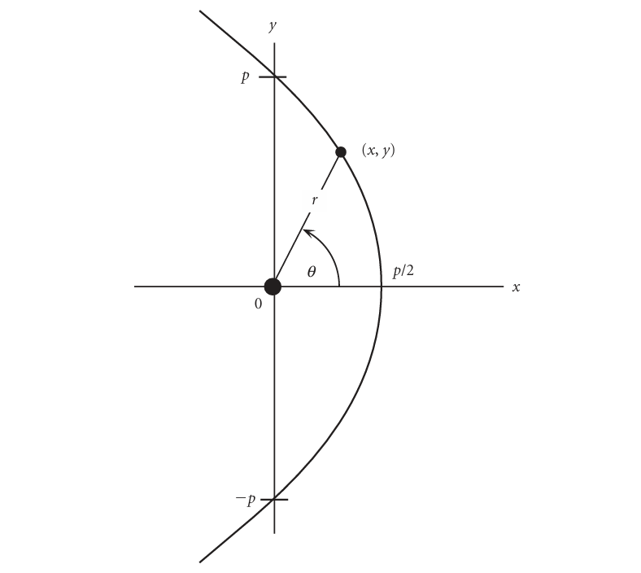

Hyperbolic Trajectories (e > 1)

A body on a hyperbolic trajectory has more than enough energy to escape the gravitational pull of the central body.1 It will continue to move away from the central body at a **non-zero** velocity even at an **infinite** distance.

Hyperbolic trajectories are characterised by their **eccentricity (e)**, a value **greater** than 1. As eccentricity increases, the hyperbola becomes "flatter"

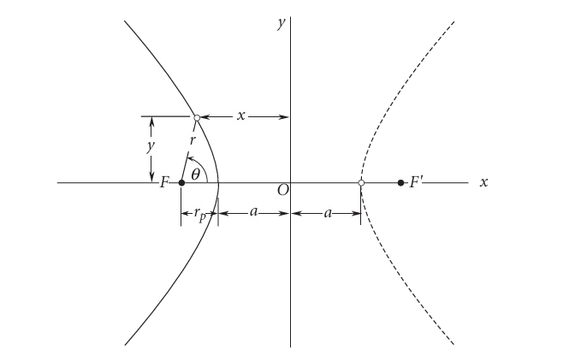

**Classical Orbital Elements:**

The six orbital elements are parameters that uniquely define the shape and orientation of an orbit in three-dimensional space, as well as the position of a body within that orbit. These elements are crucial for understanding and predicting the motion of celestial bodies, including satellites and spacecraft.

**1. Specific Angular Momentum (h)**

Specific angular momentum (h) is a measure of an object's orbital angular momentum per unit mass. It is a vector quantity that is **always perpendicular** to the orbital plane. The magnitude of h determines the **size and shape** of the orbit. A larger angular momentum corresponds to a larger and less eccentric orbit.

**2. Inclination (i)**

Inclination (i) is the angle between the orbital plane and a reference plane. For Earth-orbiting satellites, the reference plane is typically the Earth's equatorial plane. Inclination is a positive number between 0° and 180°.

* An inclination of 0° means the orbit lies **in the same plane** as the reference plane, like the equator.
* An inclination of 90° means the orbit passes **directly over the poles**.
* An inclination between 90° and 180° indicates a **retrograde orbit**, where the satellite travels in the opposite direction to the Earth's rotation.

**3. Right Ascension of the Ascending Node (Ω)**

The ascending node is the point where the orbit **crosses the reference plane from south to north**. Right ascension of the ascending node (Ω) is the angle between a reference direction in the reference plane and the ascending node. This angle is measured **eastward** in the reference plane. The reference direction is typically the **vernal equinox**, which is the direction of the sun from Earth at the start of spring.

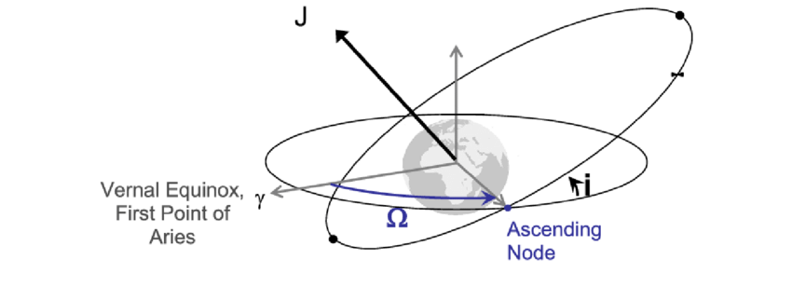

**4. Eccentricity (e)**

Eccentricity (e) is a dimensionless parameter that describes the **shape** of the orbit. It is a measure of how elongated the orbit is, ranging from 0 to greater than 1.

* **e = 0:** Circular orbit (constant distance from the central body)
* **0 < e < 1:** Elliptical orbit (distance from the central body varies)
* **e = 1:** Parabolic trajectory (escape trajectory with zero velocity at infinity)
* **e > 1:** Hyperbolic trajectory (escape trajectory with non-zero velocity at infinity)

**5. Argument of Perigee (ω)**

The argument of perigee (ω) is the angle between the ascending node and the perigee, measured in the orbital plane. Perigee is the point in the orbit **closest** to the central body. The argument of perigee is a positive number between 0° and 360°.

**6. True Anomaly (θ)**

True anomaly (θ) is the angle between the perigee and the object's current position, measured in the orbital plane. It essentially pinpoints the location of the orbiting body along its orbital path at a specific time.

**Kepler’s law of Motions:**

Johannes Kepler, a German astronomer, formulated three laws of planetary motion based on observations made by Tycho Brahe. These laws, published between 1609 and 1619, revolutionised our understanding of the solar system and laid the foundation for Newton's law of universal gravitation.

**Kepler's First Law: Law of Ellipses**

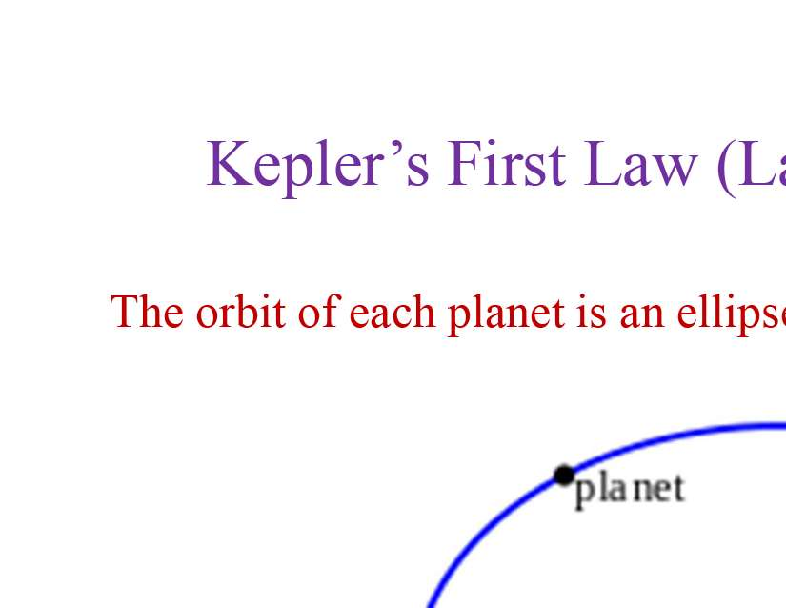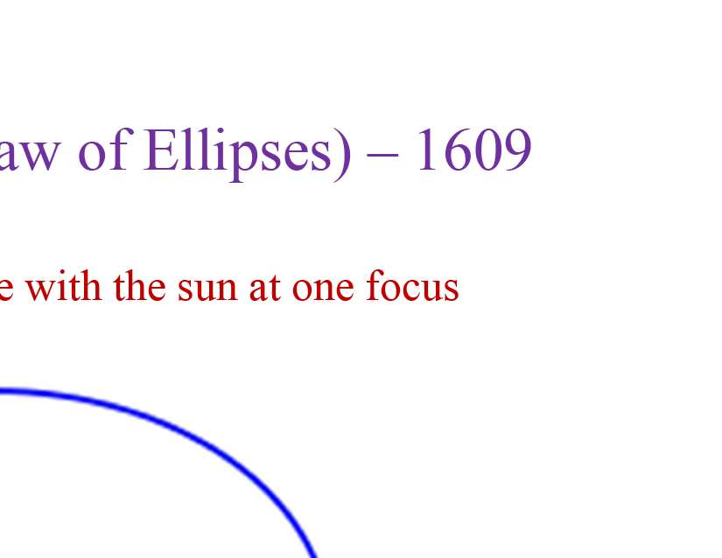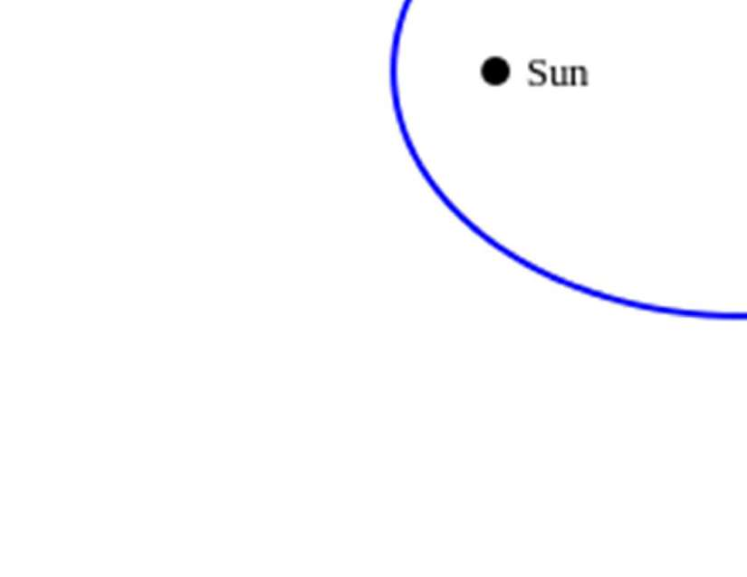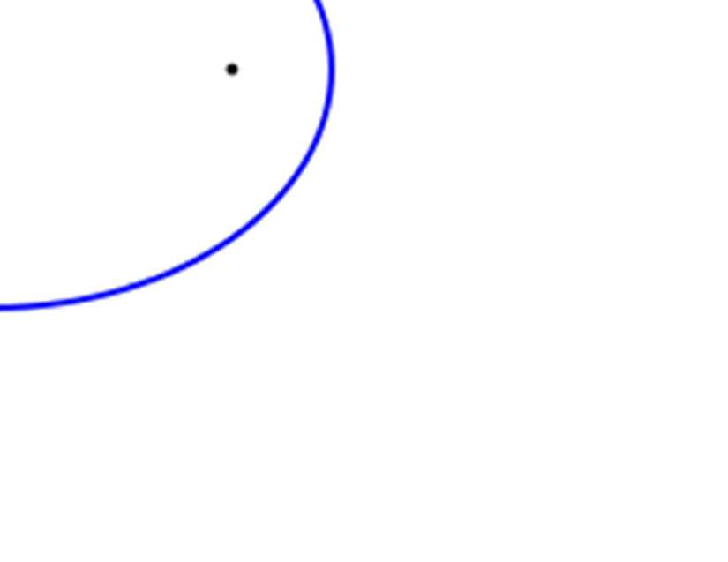

This law states that **planets move in elliptical orbits with the Sun at one of the two foci**. This replaced the long-held belief that planets moved in perfect circles.

An ellipse is a closed curve where the sum of the distances from any point on the curve to the two foci is constant. The eccentricity (e) of an ellipse determines its shape.

* e = 0: The orbit is a perfect circle.
* 0 < e < 1: The orbit is an ellipse, becoming more elongated as e approaches 1.

**Kepler's Second Law: Law of Equal Areas**

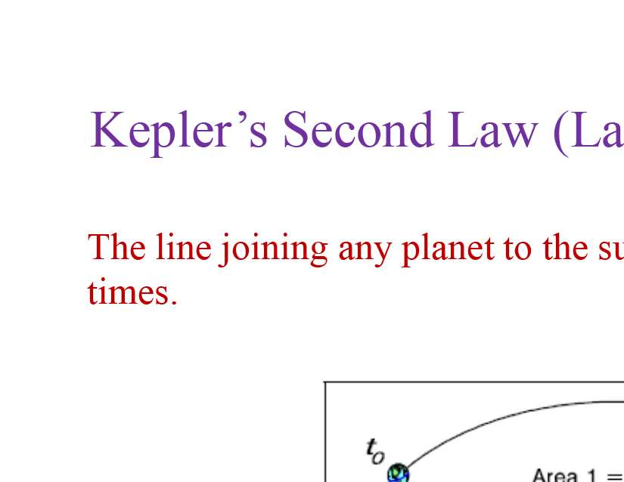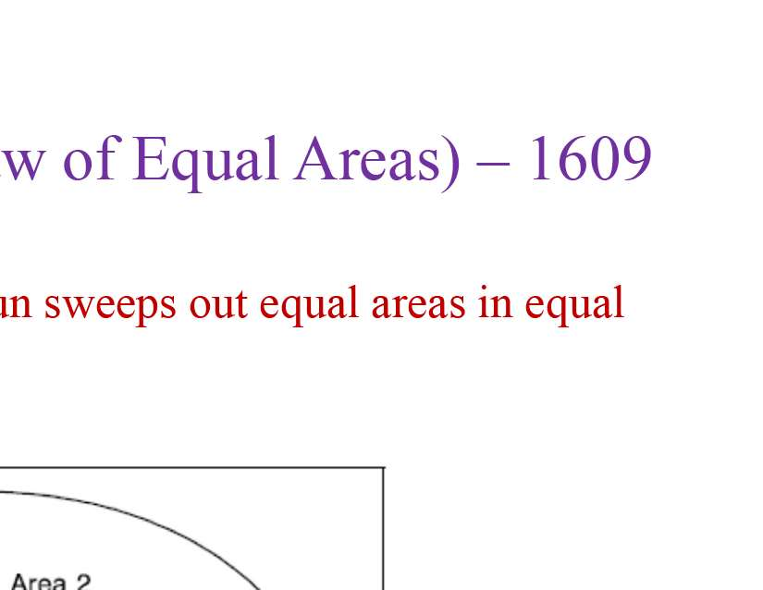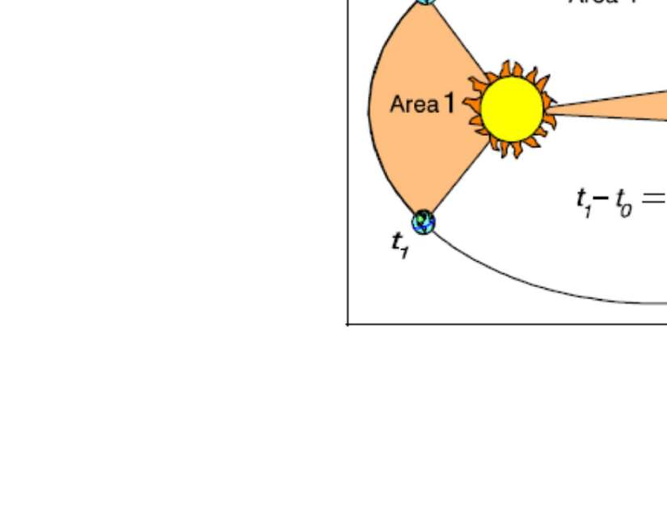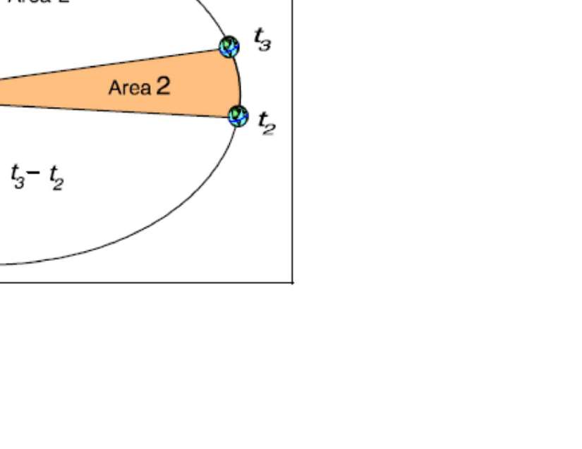

Kepler's second law states that **a line that connects a planet to the Sun sweeps out equal areas in equal times**. This implies that a planet moves faster when it is closer to the Sun (perihelion) and slower when it is farther away (aphelion).

This law is a consequence of the conservation of angular momentum. As a planet moves closer to the Sun, its orbital speed increases to maintain a constant angular momentum.

**Kepler's Third Law: Law of Harmonies**

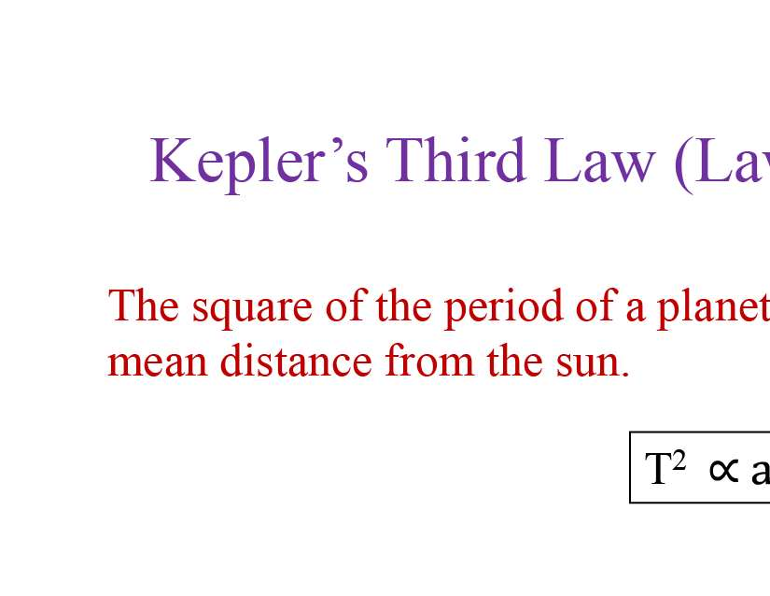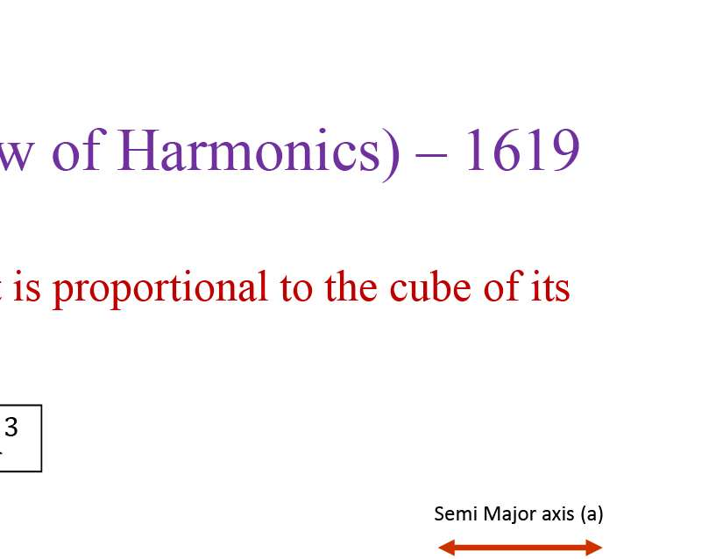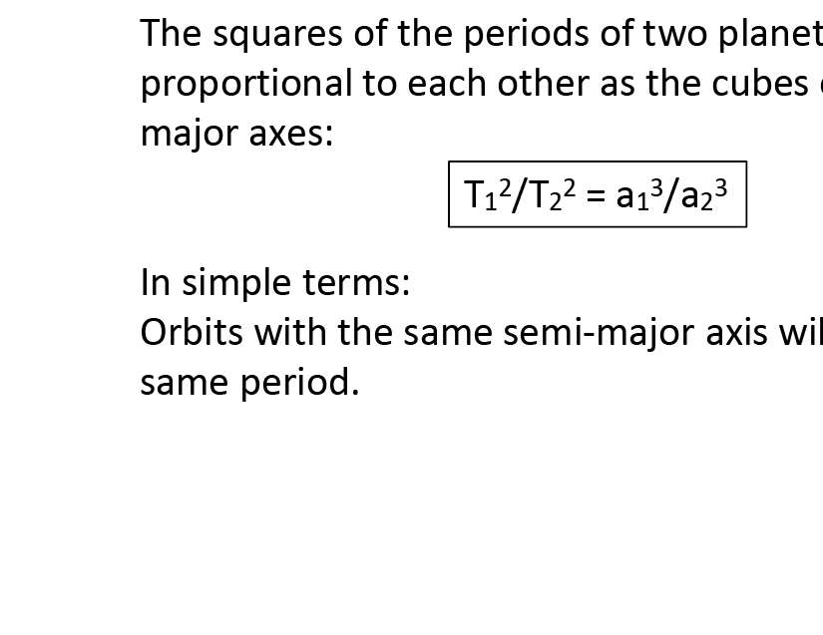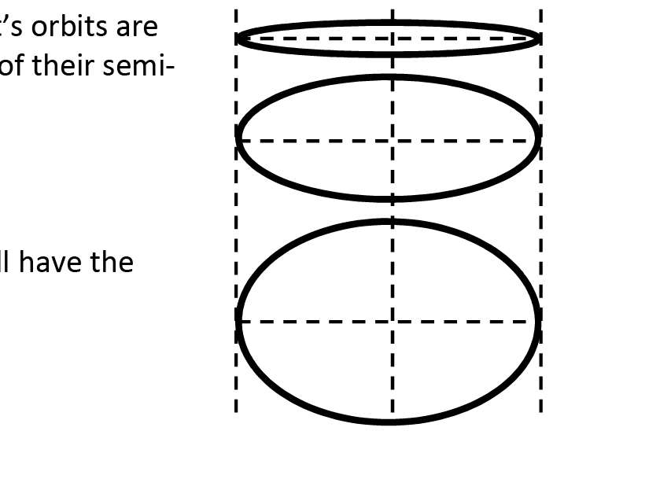

This law establishes a relationship between the orbital period of a planet and its average distance from the Sun. It states that **the square of the orbital period of a planet is proportional to the cube of the semimajor axis of its orbit**.

Mathematically, this can be expressed as:

T2 ∝ a3

where:

* T is the orbital period of the planet.
* a is the semimajor axis of the planet's orbit (half of the longest diameter of the ellipse).

This law implies that planets farther from the Sun have longer orbital periods. For example, Earth's orbital period is one year, while Mars, being farther away, has an orbital period of about 1.88 Earth years.

**Newton’s law of Gravitation**

Newton's law of gravitation states that every particle in the Universe attracts every other particle with a force that is directly proportional to the product of their masses and inversely proportional to the square of the distance between their centres.This means that the more massive the objects are, the stronger the gravitational force between them. Also, the farther apart they are, the weaker the gravitational force.

The formula for Newton's law of gravitation is:

F = G (Mm/r2)

where:

F is the force of gravity

G is the universal gravitational constant 6.6742 times 10-11 m3/kg

M and m are the masses of the two objects

r is the distance between the centres of the two objects

**Key Points**

Universal: Newton's law of gravitation applies to all objects in the Universe, from the smallest particles to the largest galaxies.

Inverse-square law: The force of gravity decreases rapidly with distance. If you double the distance between two objects, the force of gravity between them becomes four times weaker.

Proportionality to mass: The force of gravity is directly proportional to the masses of the objects. If you double the mass of one object, the force of gravity doubles.

**Weight and Free Fall**

The force of gravity exerted by a large object (like the Earth) on a much smaller object (like a person) is called weight (W). [2] Using Newton's law of gravitation, weight can be expressed as:

W = mg

where:

M is the mass of the large object (e.g., Earth)

m is the mass of the small object

g is the acceleration due to gravity = 9.81 m/s2

Free fall occurs when gravity is the only force acting on an object. In free fall, objects accelerate towards the centre of attraction (e.g., the centre of the Earth) with an acceleration of 'g'.

A person in free fall experiences weightlessness because there are no contact forces opposing the force of gravity. Although their weight is not zero, they feel as if there is no gravity acting on them.

Importance of Newton's Law of Gravitation

Newton's law of gravitation is a fundamental law of physics that explains many phenomena in the Universe:

Planetary motion: Planets orbit the Sun due to the Sun's gravitational pull.

Tides: The gravitational pull of the Moon and the Sun causes tides on Earth.

Formation of stars and galaxies: Gravity pulls matter together to form stars and galaxies.

**Satellites in Circular Orbit**

A circular orbit is the simplest type of orbit a satellite can have. In a circular orbit, the satellite travels at a constant speed and maintains a constant distance from the centre of the Earth.

* To achieve a circular orbit, the satellite needs a specific velocity that balances the Earth's gravitational pull.
* This velocity, known as circular orbital speed, is determined by the Earth's gravitational parameter and the orbital radius (the distance from the Earth's centre to the satellite).
* As the orbital altitude increases, the required orbital speed decreases, and the orbital period (the time it takes for one complete revolution) increases

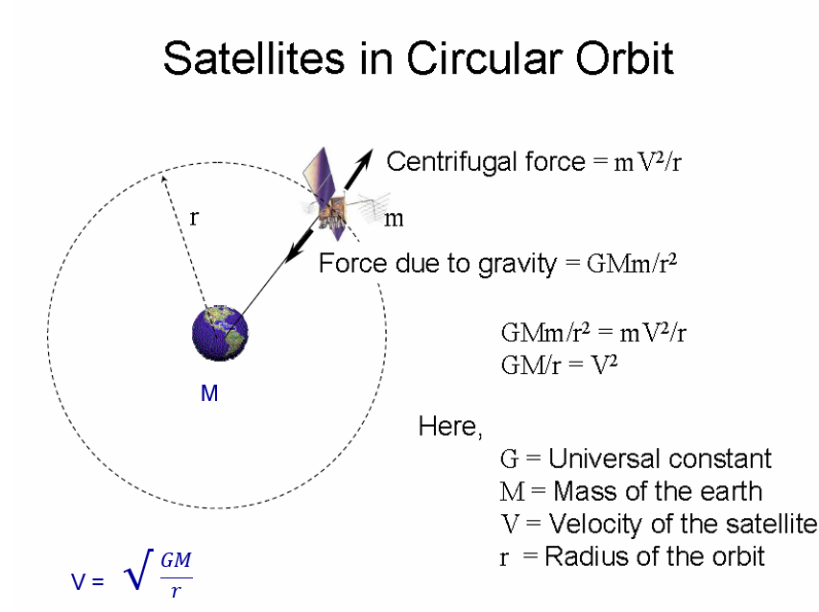

**Orbit Equation**

The orbit equation is a mathematical expression that defines the path of an object in orbit around another object, assuming a two-body system where only the gravitational attraction between the two bodies is considered. This equation arises from the conservation of angular momentum and energy in a two-body system.

**Formula**

The orbit equation is given by:

r = (h2 / μ) * (1 / (1 + e*cos(θ)))

where:

* r: The distance between the two bodies (also known as the radial distance).
* h: The specific relative angular momentum (a measure of the object's orbital momentum per unit mass).
* μ: The gravitational parameter, a product of the gravitational constant and the mass of the central body.
* e: The eccentricity, a dimensionless parameter that describes the shape of the orbit. e = 0 for a circular orbit, 0 < e < 1 for an ellipse, e = 1 for a parabola, and e > 1 for a hyperbola.
* θ: The true anomaly, the angle between the object's current position and its periapsis (the point of closest approach to the central body).

**Significance**

The orbit equation confirms Kepler's first law: planets follow elliptical paths around the sun. Similarly, any object in a two-body system follows a conic section path - ellipses, parabolas or hyperbolas.

Applications

The orbit equation can be used to determine the position of an orbiting object at any given time. It's fundamental to understanding the dynamics of orbital motion and forms the basis for more complex calculations, including:

**Time since periapsis:** Calculating the time taken by an object to travel between two points on its orbit.

**Orbital maneuvers:** Planning changes in a spacecraft's orbit, such as Hohmann transfers and plane changes.

**Preliminary orbit determination:** Determining the orbit of a satellite based on observations from Earth

**The Energy Law in Orbital Mechanics**

The energy law, also known as the vis-viva equation, is a fundamental principle in orbital mechanics. It states that the total mechanical energy of an object in orbit remains constant throughout its trajectory, assuming that only gravitational forces are acting upon it. This conservation of energy principle is a consequence of Newton's law of universal gravitation and Newton's second law of motion.

**Kinetic and Potential Energy**

The total mechanical energy of an orbiting object is the sum of its kinetic energy and potential energy.

Kinetic energy is the energy associated with the object's motion. It depends on the object's mass and speed. The faster the object moves, the greater its kinetic energy.

Potential energy is the energy stored within an object due to its position in a gravitational field. In orbital mechanics, the potential energy is negative because it represents the energy required to move the object infinitely far away from the attracting body. As the object moves closer to the attracting body, its potential energy becomes more negative.

**Mathematical Expression**

The energy law is expressed mathematically as follows:

ε = v2/ 2 - μ / r

Where:

* ε represents the specific mechanical energy per unit mass, a constant value for a given orbit.
* v is the object's orbital speed.
* μ is the gravitational parameter of the central body (e.g., Earth).
* r is the distance between the object and the central body.

**Importance and Applications**

The energy law has several important implications and applications in orbital mechanics:

* It helps determine the shape of an orbit. If the specific energy is negative, the orbit is elliptical. If it's zero, the orbit is parabolic (escape trajectory). If it's positive, the orbit is hyperbolic.
* It helps calculate the speed of an object at any point in its orbit, given its distance from the central body.
* It plays a crucial role in understanding orbital manoeuvres, such as Hohmann transfers, which require changes in the object's energy to transition between orbits.

**Example**

Consider a satellite in a circular orbit around Earth. As the satellite maintains a constant distance from Earth, its potential energy remains constant. According to the energy law, its kinetic energy (and therefore its speed) must also remain constant

**Parabolic Trajectories**

A parabolic trajectory occurs when an object is moving with just enough energy to escape the gravitational pull of a central body. This specific energy level results in an unbound trajectory, meaning the object will not return to orbit the central body but will continue to move infinitely far away.

**Key Characteristics**

**Eccentricity (e):** The eccentricity of a parabolic trajectory is always equal to 1. This distinguishes it from elliptical orbits (e < 1) which are closed and bound, and hyperbolic trajectories (e > 1) which also represent escape trajectories but with a higher energy level.

**Energy:** The specific energy of an object on a parabolic path is zero. This means the object's kinetic energy is precisely balanced by its potential energy at every point in its trajectory. As the object moves farther away, its velocity decreases, approaching zero at infinity.

**Speed:** The speed of an object on a parabolic trajectory can be determined using the following equation:

V = square root ( 2μ /r)

where:

* v is the object's speed.
* μ is the gravitational parameter of the central body.
* r is the distance between the object and the central body.

**Flight Path Angle (γ):** The flight path angle is the angle between the object's velocity vector and the local horizontal. For parabolic trajectories, the flight path angle is always half the true anomaly (θ)

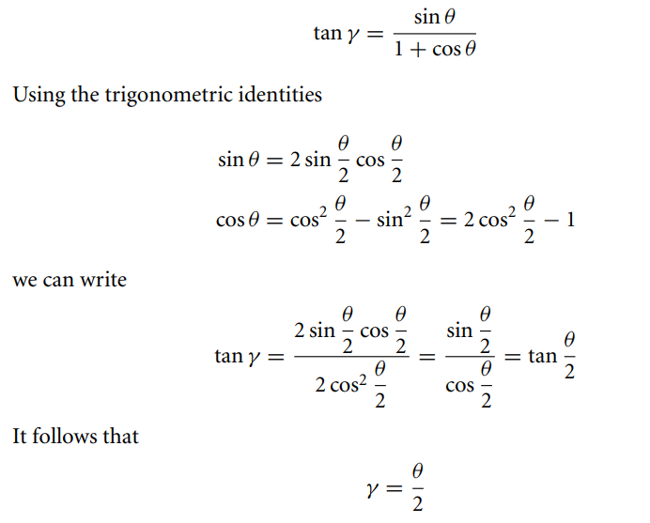

Hyperbolic Trajectories:

A hyperbolic trajectory represents the path of an object moving with more than enough energy to escape the gravitational pull of a central body. Unlike an elliptical orbit, which is closed and repeats, a hyperbolic trajectory is open and the object will never return. It represents a type of unbound trajectory similar to a parabolic trajectory, but with a higher energy level.

**Key Characteristics**

**Eccentricity (e):** Hyperbolic trajectories have an eccentricity greater than 1. This distinguishes them from elliptical orbits (0 < e < 1), which are closed and bound, and parabolic trajectories (e = 1), which also represent escape trajectories.

**Energy:** The specific energy (energy per unit mass) of a hyperbolic trajectory is positive. This positive energy indicates that the object possesses more kinetic energy than potential energy, allowing it to overcome the gravitational pull of the central body and escape to infinity.

**Hyperbolic Excess Speed (v∞):** This represents the speed of the object at an infinite distance from the central body. It signifies the residual speed the object retains after escaping the gravitational influence.

**Turn Angle (δ):** This is the angle through which the object's velocity vector is rotated as it passes by the central body. It indicates the degree of deflection caused by the central body's gravity.

**Shape:** The shape of a hyperbolic trajectory is a hyperbola, a curve with two separate branches that extend to infinity. It's defined by its periapsis, the point of closest approach to the central body, and its two asymptotes, lines that the trajectory approaches as it extends to infinity.

**Equations**

The following equations are relevant to hyperbolic trajectories:

**Orbit Equation:** This equation defines the path of the object:

If e > 1, the orbit formula,

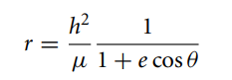

Clearly, the denominator of Equation goes to zero when

cos θ = −1/e.

We denote this value of true anomaly

**θ∞ = cos−1 (−1/e)**